GRATE
EXPECTATIONS

As traffic volumes continue to increase across all major freeways in Melbourne, attention has drifted towards the suitability of existing drainage grate standards to cope with ever increasing traffic loads.
A string of incidents involving bolted down grates dislodging from their frames on major motorways sparked an investigation of existing grates in trafficable lanes. It was found that although the grates had successfully tested to Class D of Australian Standard AS3996: Access Covers and Grates, all trafficable grates were showing significant signs of fatigue.
Road Safety Grating was invited to design and develop a system of bolted down grates that would be capable of withstanding the fully loaded B-Doubles travelling at 100 km/h that had caused the problems for existing grates. Road Safety Grating immediately utilised its “weaved” grate design. HRL Technologies carried out a 2.5 million repetition fatigue test on a sample grate, concluding “one could take the life of the grate to be infinite”.
With the strength and durability of the grate established, Road Safety Grating began to focus on the design of the bolt down method. Critical to the securing of the grate to the ground was a redevelopment of the traditional angle iron frame, as in some instances entire frames had been ripped out of the ground. A T-section ‘freeway-style’ frame was developed, incorporating anchoring reo and allowing a stronger and more secure bolting method to be implemented, as well as ensuring the frame could be better anchored to the ground.
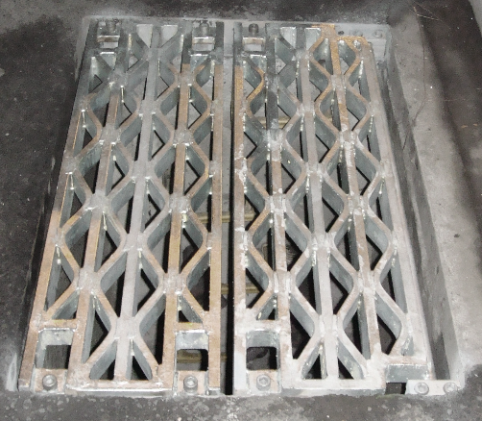
A Road Safety Grating grate installed on a motorway.
The use of a T-section frame allowed the installation of a positive preloaded bolting system, engineered to minimise risk of failure due to fatigue loading from repeated vehicle traffic.
The final stage of testing the grates’ suitability for major motorways was to perform a dynamic strain test on an installed grate. A grate installed on the Steele Creek Bridge of the Western Ring Road (M80) was chosen.
With a road closure, strain gauges were fitted to measure axial bolt forces and grate strain during dynamic vehicle traffic events. Additionally, internal bolt strain gauges were fitted to the bolts and two studs that hold the frame to the bridge deck to measure the force-strain relationship during dynamic impact. Finally linear strain gauges were fitted to the underside of the grate.
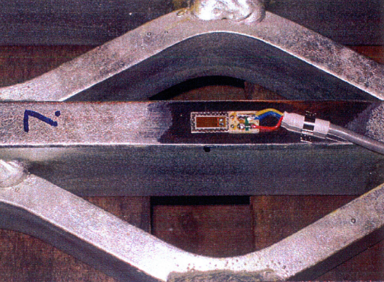
A linear strain gauge fitted to the grate.
With the measuring equipment fitted a 62.5 tonne B-Double with 9 axles made four runs over the grate and frame at 100 km/h, with the results recorded.
The results from the strain gauges fitted to the bolts showed that the dynamic forces in the bolts were less than 5% of what was already preloaded, showing the bolt down system to be more than adequate under large dynamic loads. Forces in the studs tying the frame to bridge deck were also found to be minimal, demonstrating that the frame is more than adequately tied to the bridge deck. The fatigue life of the grate determined from the maximum strain gauge result was found to be in excess of one billion cycles.
The results showed that Road Safety Grating’s design had eliminated all the causes of grate dislodgements in Melbourne’s freeways. The use of a T-Section frame had ensured the frame could be effectively anchored to the ground, while also allowing a more stringent bolt down method to be implemented. The preloading of the bolts eliminated significant stress in the bolts under dynamic loads, ensuring the bolts would not fail and subsequently allow the grate to become dislodged.
The spate of grate dislodgements that drove Road Safety Grating to develop a superior bolted down grate is evidence that the Australian Standard for Access Covers and Grates is inadequate in determining standards for trafficable grates in freeways. The ever increasing large dynamic loads that freeway grates are subjected to cannot be tested by AS3996’s recommended type load testing. Additionally, AS3996’s dislodgement prevention guidelines are insufficient for large dynamic loads, only requiring that the grate depth exceed 50mm without any other provisions.
Road Safety Grating is proud to be leading innovation in grate and bolt down techniques for grates subjected to large dynamic loads in freeways and helping increase safety and security on Melbourne’s freeways. For further information please contact Road Safety Grating.
Road Safety Grating
13 Healey Rd, Dandenong South, VIC 3175
PH: (03) 9238 5888 Fax: (03) 9238 5800
Email: sales@grating.com.au
Web: www.grating.com.au
